SmartCare v0.4 - Domain Implementation Workbook
Week 7 student resource

1. UML-to-Code Trace
UML element | Python element | Implemented? | Notes
Class Patient | class Patient | yes
Patient: patientId, name | _patient_id, _name | yes | Both are checked in the constructor and raise ValueError if empty.
Patient: getName(), matchesId(patientId). | get_name(), matches_id(patient_id) | yes
Class Practitioner | class Practitioner | yes
Practitioner: name | _name | yes | Checked in constructor
Practitioner has 0..* Appointments. | self._appointments (list) | yes | Starts empty
Practitioner: isBusyAt(time). | is_busy_at(time: str) -> bool | yes
Practitioner: addAppointment(appointment). | add_appointment(appointment) | yes
Class Appointment | class Appointment | yes
Appointment: appointmentTime | _appointment_time (str) | yes | String has to be exact to detect duplicate times.
Appointment: status | _status (AppointmentStatus) | yes | Enum instead of string.
Appointment is for 1 Patient. | _patient | yes | One-way reference.
Appointment is with 1 Practitioner. | _practitioner | yes
Appointment: isActive() | is_active() | yes
Appointment: cancel() | cancel() | yes

2. Domain Invariants
Class | Invariant / rule | How protected
Patient | Name and id are never empty. | Raises value error if they are.
Patient | Id and name are not changed from outside. | They are private attributes
Practitioner | Name, id and Specialty are never empty | Raises value error if they are.
Practitioner | Appointments are only added through the class. | _appointments is private and only changed through add_appointment
Appointment | Patient, Practitioner and time are never empty. | Raises value error if they are.
Appointment | Practitioner never has 2 active appointments at the same time | practitioner .is_busy_at(time) doesn't allow it.
Appointment | A new appointment starts booked | The constructor sets it as booked and status is not a parameter.
Appointment | Status only changes through cancellation. | _status is private and get_status() is read only.
Appointment | A cancelled appointment cannot be cancelled again. | You can only cancel active appointments.

3. Composition / Inheritance Decisions
Relationship | Decision | Rationale
Appointment and Patient | One way association | A patient exists before and after any appointment so the appointment doesn't own it. The appointment holds a reference to the patient, not a copy of the name.
Appointment and Practitioner | 2 way association | Practitioner exists independently but must see its own appointments to use is busy at.
Appointment inheriting from patient | No inheritance | An appointment is an event involving a patient, not a kind of patient.
Status values as subclasses of Appointment. | Rejected, an enum is used. | Status has no behaviour of its own.
Clinic, repositories, services | Rejected | No requirements support them.

4. AI Pair-Programming Record
AI contribution | Conforms? | Decision | Reason | Verification
Two-value AppointmentStatus enum. | yes | Accepted | Matches the UML. | Status prints Booked after booking and Cancelled after cancelling.  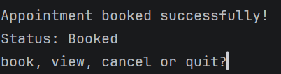  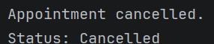
Constructor checks for missing fields and a busy practitioner. | yes | Accepted | Matches my CRC cards. | The same practitioner and time twice gives a denial. Empty and None values give errors.  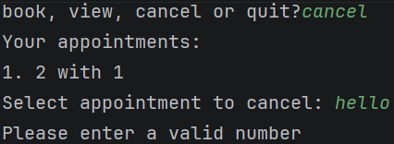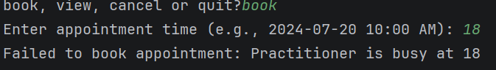
Registers the appointment with a practitioner. | yes | Accepted | is_busy_at can only see listed appointments. | Cancel and then rebook the same time succeeds.  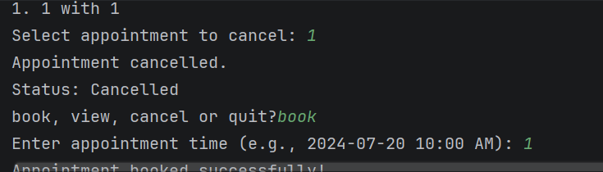
Main | No its tests code. | modified | Changed to a loop so a denied booking can be tested, exit() removed, cancel status fixed. | Menu run showing book, deny, cancel and quit.  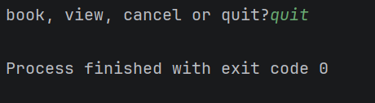
Offer of repositories and services | No | Rejected | No requirement supports them. | Not in code.

5. Updated UML
Insert updated UML only if implementation revealed a justified design change. Explain every change.

Appointment
Patient
Practitioner
1
1
0*
0*
-appointmentTime: DateTime
+cancel():none
+isActive():boolean
+getAppointmentTimer(): string
+getStatus(): Appointmentstatus
-patientId:String
-name:String
+getName():String
+getPatientId():String
+matchesId(id):boolean
-name:String
-practitionerId:String
-specialty:String
+getName():String
+getPractitionerId():String
+getSpecialty():String
+isBusyAt(time):boolean
+addAppointments():none

Appointmentstatus
0*
1

